SIMATS ENGINEERING

ASSESSMENT TOOL 2

COURSE NAME: Database Management Systems COURSE CODE: CSA0504

COURSE OUTCOME COVERED

CO1: Analyse DBMS architecture, different data models, schema types, and design ER/EER diagrams, relational schemas for case-based scenarios by identifying entities and relationships. (BL1, BL2)

Activity Tool : Concept Mapping (Medium) Assessment Tool Weightage: 20%

QUESTIONS
Q.N  o | Question | Bloom's Level
1 | Construct a concept map linking the following terms: DBMS, Schema, Instance, Data Model, ER Diagram, Entity, Attribute, Relationship. | BL2 –  Understand
2 | Create a concept map for the three-level ANSI/SPARC architecture showing data independence at each level. | BL2 –  Understand
3 | Map the relationship between file-based systems and database systems, highlighting the problems solved by DBMS. | BL2 –  Understand
4 | Design a concept map for ER diagram components: entity, weak entity, attribute types, relationship types, and participation constraints. | BL2 –  Understand
5 | Construct a concept map comparing Hierarchical, Network, and Relational data models with their key properties. | BL2 –  Understand
6 | Develop a concept map for the EER model showing how it extends the basic ER model with generalization, specialization, and aggregation. | BL2 –  Understand

7 | Create a visual concept map for the DBMS software architecture, illustrating the flow from user request to data retrieval. | BL2 –  Understand
8 | Map the data models discussed in CO1 to real-world applications and explain the suitability of each model. | BL2 –  Understand
9 | Construct a concept map for schemas and instances, showing how they relate to physical and logical data independence. | BL2 –  Understand
10 | Design a concept map for the roles and responsibilities in a DBMS environment: DBA, End User, Application Developer. | BL1 –  Remember

Code of Conduct:

Criteria |  | Weightage |  | Level 4 (Exemplary) |  | Level 3 (Proficient  ) |  | Level 2 (Developi ng  ) |  | Level 1 (Beginning)
Concept Identificatio n |  | 25% |  | Identifies all key concepts from literature accurately and comprehensiv el  y |  | Identifie s most  k e y concept s with m i n o r omissio ns |  | Identifies limited concepts; some are irrelevant or missing |  | Fails to  identify essential concepts
Linkages |  | 25% |  | Establishes clear, meaningful, and accurate relationships betwee  n concep ts |  | Sho ws corre ct  relationshi ps with minor gaps |  | Relationshi p s are weak, unclear, or partially incorrect |  | No meaningful relationships established
 | Organizatio n |  | 20% |  | Concepts are well-structured hierarchically with logical flow and grouping |  | Mostly organiz ed with minor structur al issues |  | Some organizati on but lacks clear hierarchy |  | No logical organizatio n or structure

I Shaik mahamad Sohail(192511120) certify that this submission is my original work and that I have adhered to the guidelines specified for this assessment. I understand that any violation of academic integrity rules will result in disciplinary action.

Signature of the student: Sohail

RUBRICS FOR CALCULATION:

Integratio n of Literature | 20% | Integrates multiple studies effectively to show connections and compariso ns | Shows some integratio n of literature | Limited integratio n; mostly isolate  d concep ts | No integration  of literature evidence
Clarity | 10% | Concept map is clear, neat, visually structured, and easy to interpret | General ly clear with minor readabili ty issues | Clarity i s  reduced; difficult t o  interpret in  parts | Poorly presented and hard to understand

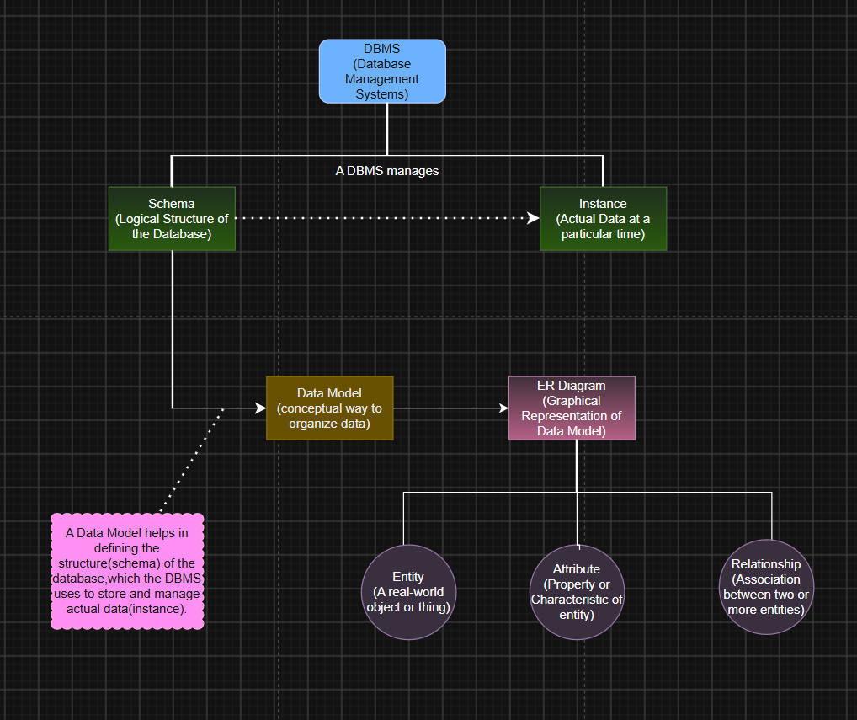
Construct a concept map linking the following terms: DBMS, Schema, Instance, Data Model, ER Diagram, Entity, Attribute, Relationship.

DBMS (Database Management System)
  - Software used to create, store, retrieve, and manage databases.
  - Ensures data security, consistency, and integrity.

Schema
  - The logical structure or blueprint of a database.
  - Defines tables, columns, constraints, and relationships.
  - Changes rarely.

Instance
  - The actual data stored in the database at a particular time.
  - Changes whenever data is inserted, updated, or deleted.

Data Model
  - A set of concepts used to organize and describe data.
  - Defines how data is stored and related.
  - Examples: Relational Model, Hierarchical Model.

ER Diagram (Entity-Relationship Diagram)
  - A graphical representation of a database.
  - Shows entities, attributes, and relationships.

  - Used during database design.

Entity
  - A real-world object or thing.
  - Examples: Student, Employee, Customer.

Attribute
  - A property or characteristic of an entity.
  - Examples: Student_ID, Name, Age.

Relationship
  - Represents the association between two or more entities.
  - Example: Student enrolls in Course.

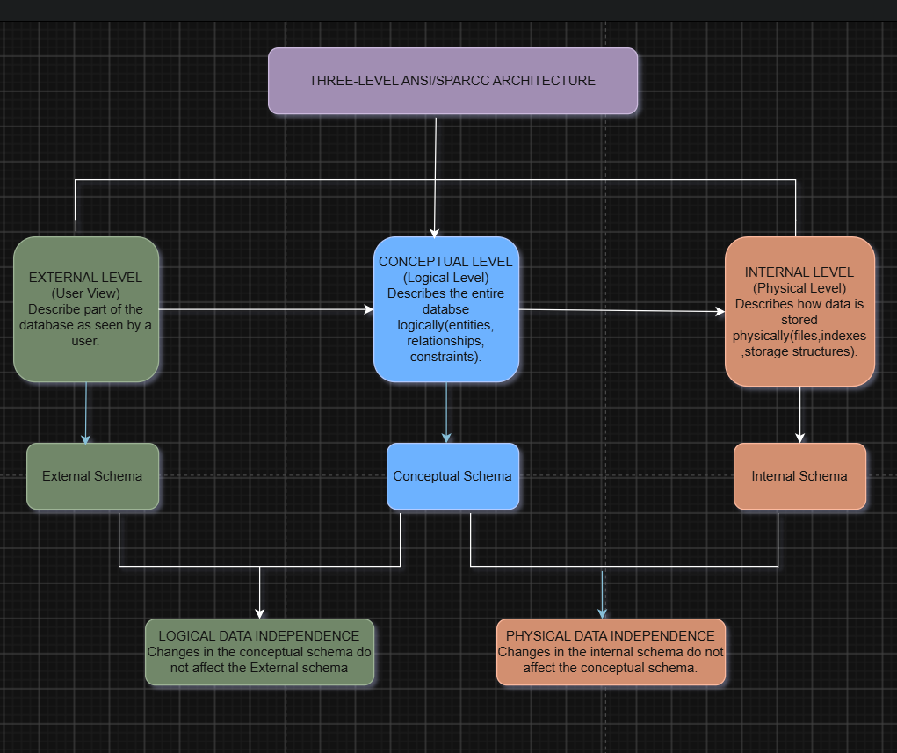
Create a concept map for the three-level ANSI/SPARC architecture showing data independence at each level.

External Level (User View)
  - Represents different views for different users.
  - Shows only the data required by each user.
  - Provides security by hiding unnecessary information.

Conceptual Level (Logical View)
  - Describes the complete logical structure of the database.
  - Defines entities, relationships, attributes, and constraints.
  - Independent of physical storage details.

Internal Level (Physical View)
  - Describes how data is physically stored.
  - Includes file organization, indexes, and storage methods.
  - Focuses on database performance and storage efficiency.

Data Independence
  - Logical Data Independence: Changes in the conceptual schema do not affect external user views.
  - Physical Data Independence: Changes in the internal schema do not affect the
conceptual schema.

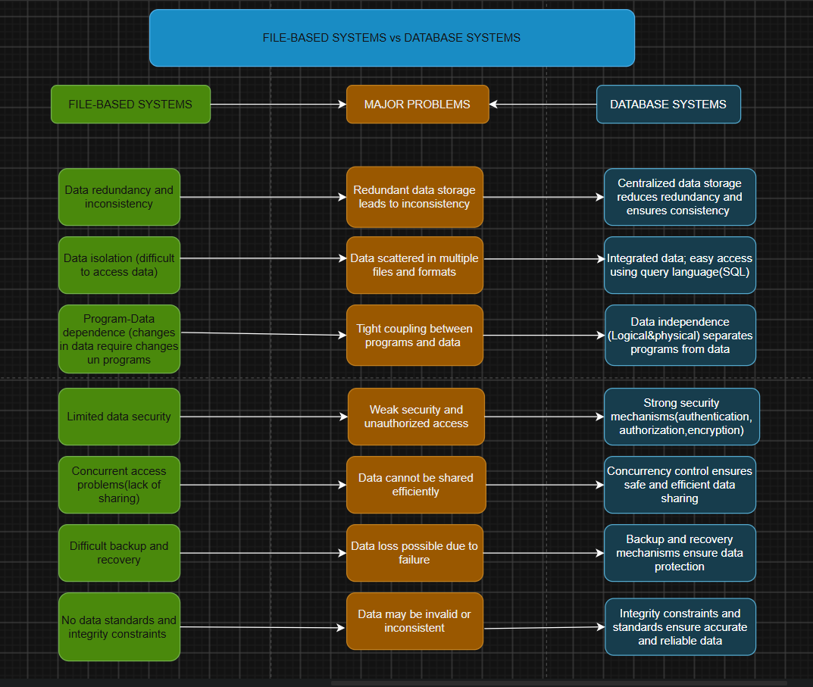
Map the relationship between file-based systems and database systems, highlighting the problems solved by DBMS

File-Based Systems
  - Stores data in separate files.
  - Leads to data redundancy and inconsistency.
  - Difficult to access, update, and share data.
  - Limited security and backup facilities.
  - No data independence.

Database Systems (DBMS)
  - Stores data in a centralized database.
  - Reduces data redundancy and improves consistency.
  - Provides easy data access using SQL.
  - Supports security, backup, and recovery.
  - Offers logical and physical data independence.

Problems Solved by DBMS
  - Eliminates data redundancy and inconsistency.
  - Integrates data into a single database.
  - Provides efficient data retrieval.
  - Controls concurrent access by multiple users.
  - Enhances data security.
  - Supports backup and recover

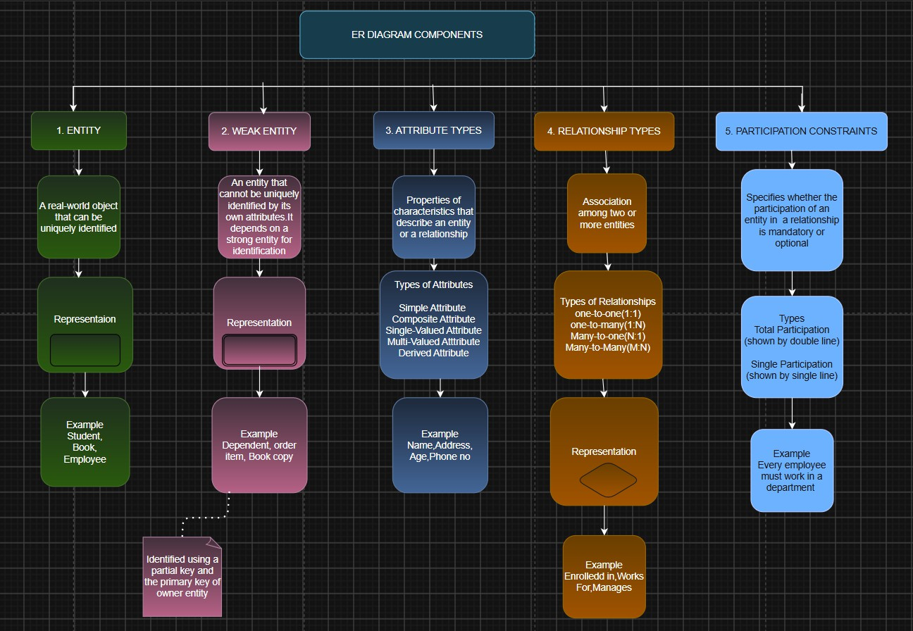
Design a concept map for ER diagram components: entity, weak entity, attribute types, relationship types, and participation constraints.

Entity
  - A real-world object or thing that can be identified.
  - Represented by a Rectangle.
  - Examples: Student, Employee, Department.

Weak Entity
  - An entity that cannot be uniquely identified by its own attributes.
  - Depends on a strong (owner) entity.
  - Represented by a Double Rectangle.
  - Example: Dependent (depends on Employee).

Attribute Types
  - Simple Attribute: Cannot be divided (e.g., Age).
  - Composite Attribute: Can be divided into sub-parts (e.g., Address → Street, City, PIN).
  - Single-Valued Attribute: Has only one value (e.g., Roll Number).
  - Multi-Valued Attribute: Has multiple values (e.g., Phone Number).
  - Derived Attribute: Obtained from another attribute (e.g., Age from Date of Birth).
  - Key Attribute: Uniquely identifies an entity (e.g., Student_ID)

Relationship Types
  - Shows the association between two or more entities.
  - Represented by a Diamond.
  - Types:
    - One-to-One (1:1)
    - One-to-Many (1:N)
    - Many-to-Many (M:N)

Participation Constraints
  - Specify whether an entity must participate in a relationship.
  - Total Participation: Every entity must participate (Mandatory).
  - Partial Participation: Participation is optional.5. Construct a concept map comparing Hierarchical, Network, and Relationaal data models with their key properties.

Construct a concept map comparing Hierarchical, Network, and Relational data models with their key properties.
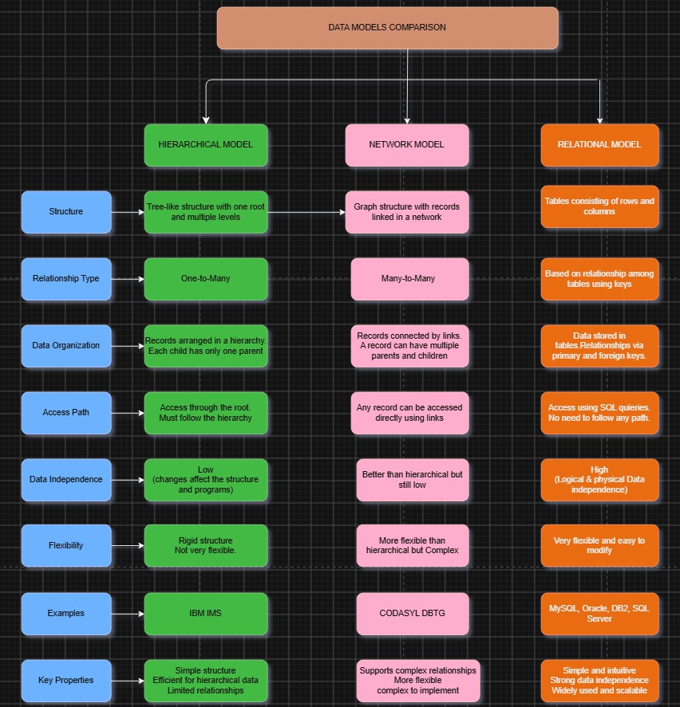

Hierarchical Data Model
  - Organizes data in a tree structure.
  - Each child has only one parent.
  - Supports one-to-many (1:M) relationships.
  - Simple but less flexible.

Network Data Model
  - Organizes data in a graph structure.
  - A child can have multiple parents.
  - Supports many-to-many (M:N) relationships.
  - More flexible than the hierarchical model.

Relational Data Model
  - Organizes data in tables (rows and columns).
  - Tables are connected using primary and foreign keys.
  - Supports SQL for easy data access.
  - Most widely used data model in modern times.

